Table of Contents

Main (Intro, Title, End) 3

Chapter (1, 2, 3…) 3

Path (Shared or 1 bzw. 2)) 3

Scene 3

Objects 3

Story 4

---------Intro---------- 4

---------Chapter Home--------- 4

Shared Path 4

General

**Setting**

Futuristic, Post-Apocalyptic Survival, Mokoko

**Theme**

Dark Fantasy (Monsters, Cum Gobblers etc)

**Goal**

To get from the East to the West coast, to sail to europe and survive the bombies

Basic Story

Player lives in Texas, somehow people are getting infected and start to continuesly suck dicks and bite them off. One day the Gov. Issues a whole bombing of the US to eliminate the Dick Eaters (Main Enemy)

**Endings**

You get points, based on how well you do, if you don’t get enough points, you miss the last boat, leaving you to die (and your dick gets sucked dry and cut off)

**Stating Point**

Nuclear war in the world. Mokoko doesn’t get informed, since it’s so far away. The explosion didn’t reach the island, but the radiation did. Combined with some Mokoko Seeds the radiation had some horrifying effects on humans, transforming them into monsters.

Legend

Main (Intro, Title, End)

Chapter (1, 2, 3…)

* For easy selection

Path (Shared or 1 bzw. 2))

* For differences in story paths

Scene

* Splits Path even further for saving capabilites

Objects

* Interactable Objects in Scene
* Template ( red is mandatory)

* 

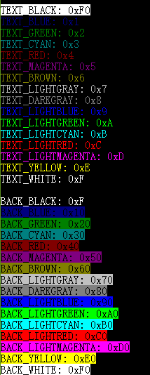Colors:

Story

Intro

Chapter Home

Shared Path

You wake up.  
Its dark outside.  
Your dad went to buy milk, he still hasn’t returned yet… Your mom has nightshift today